Module (HTML 5)

1.What are the new tags added in HTML 5?

Ans. HTML5 introduced several new tags to improve web development by enhancing semantics, multimedia capabilities, and form controls.

1. article

2. aside

3. details

4. figcaption

5. figure

6. footer

7. header

8. main

9. mark

10. nav

These elements were introduced to handle multimedia content without the need for external plugins:

1. audio

2. video

3. source

4. track

HTML5 introduced new form elements to improve user interaction and data input:

1. datalist

2. keygen

3. output

These elements provide interactive features to improve user experience:

1. progress

2. meter

3. summary

2.How to embed audio and video in a webpage?

Ans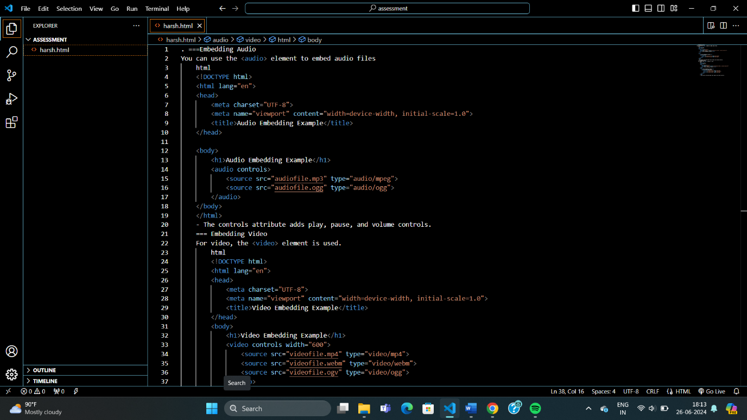

3.Semantic element in HTML5?

Ans. These elements make the HTML more readable and easier to maintain, both for developers and for search engines that parse the content.

1. header: Represents a container for introductory content or a set of navigational links. A header element typically contains one or more heading elements (<h1> to <h6>), a logo, or any other introductory content.

2. nav: Defines a set of navigation links. It is intended for major block of navigation links such as a table of contents or a menu.

3. section: Represents a generic section of a document, typically with a heading. A section element groups content into thematic sections.

4. article: Represents a self-contained composition in a document, page, application, or site, which is intended to be independently distributable or reusable, such as a blog post or news article.

5. aside: Represents a portion of a document whose content is only indirectly related to the document's main content. It is often used for sidebars.

6. footer: Defines a footer for a document or section, typically containing information about the author, copyright data, links to related documents, etc.

7. main: Specifies the main content of a document. The content inside the main element should be unique to the document and not repeated across pages (e.g., blog post, main article).

8. figure and figcaption: The <figure> element is used to encapsulate a visual representation of some content, such as an image, diagram, or code snippet. The <figcaption> element is used to provide a caption for the figure.

4.Canvas and SVG tags

Ans. Both and are HTML tags used for graphics rendering.

\* Canvas (): provides a rectangular area where you can draw graphics dynamically using JavaScript.

\* SVG (Scalable Vector Graphics): is a markup language for describing two-dimensional vector graphics.